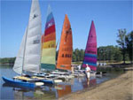
Brandermill Sailing Club – Membership Application
BSC, c/o Tom Anderson, 5716 Harbour Ridge Rd, Midlothian, VA 23112
treasurer@sailbrandermill.org

Primary Member Application Information
First Name: |  |  | Middle Initial: |  |  | Last Name:
Nick Name:
Name of Spouse:
Family Members:

Primary Member Contact Information
Street Address:
City: |  |  |  | State: |  | Zip Code:
Home Phone: |  |  |  | Primary Member - Membership Eligibility
Cell Phone: |  |  |  | Brandermill Resident:
Work Phone: |  |  |  | Woodlake Resident:
Email Address 1: |  |  |  | Membership Type:
Email Address 2: |  |  |  | Member Sponsor if a non Brandermill or Woodlake Resident:

Boat Information – Do you own (check all that apply)
Sailboat: |  | Make and Year:
Canoe/Kayak: |  | Make
Pontoon Boat: |  | Make

check all Activities You Are Interested in Participating In
Club Officer: |  | Racing |  |  | Teach Sailing Lessons
Club Socials: |  | Race Committee: |  |  | Take Sailing Lessons
Club Publicity: |  | Crewing on Other Boats
Club Membership: |  | Manual Powered Boats:

Application Fees
Choose ONE type of membership: | Annual Dues
Social Member – All household members can attend all social & sailing events this year
($35 per year per family):
Racing Member – Includes all Social Member right plus enter as boat Captain in all BSC-hosted regattas
($50 per year per family):

Please complete the application and return it with a check (payable to “Brandermill Sailing Club”) to cover the annual membership dues, or use the Zelle app to pay treasurer@sailbrandermill.org (QR Code on the last page). Applications should be mailed to Brandermill Sailing Club, c/o Tom Anderson, 5716 Harbour Ridge Rd, Midlothian, VA 23112.

I understand the scope and nature of the above activity.

I understand my responsibility to exercise due care in the performance of the activity for the safety of myself, my family, and the other participants.

As a participant in this activity, I understand that I assume all risks and liability that may arise from my involvement and participation in this activity. I further agree to hold harmless the Brandermill Sailing Club and the Brandermill Community Association its officers, members, volunteers, heirs and assignees from any and all claims, damages, actions, liability and expense, now and in the future, in connection with any and all personal and bodily injury and/or damage to my person, be it foreseen or unforeseen.

Signature: ________________________________________________________

Date: ______________________

Name of parent if a minor: ___________________________________________

Signature of parent if a minor: _________________________________________

Form revised 02-04-2023.

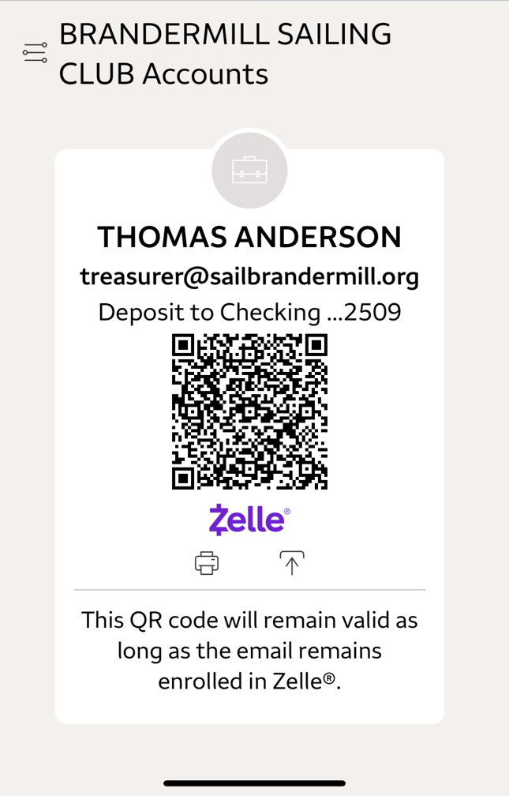
Please be sure to include your full name with your Zelle payment, as well as a note saying “Membership Dues for 2023”

